

Disco Dilemma
Problem #10 | Novice/Advanced | 11 Points

C programmers: your program name must be: prob10.exe
JAVA programmers: your program name must be prob10.class

Task Description
Disco Stu has purchased some colorful floor panels for the dance floor of his club. Every Friday his employees will rearrange the panels so the disco dance floor will have a new and exciting look. He has purchased a large supply of panels with seven different shapes. Each panel consists of four 1-foot squares as depicted below:

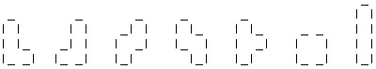

1 2 3 4 5 6 7

Disco Stu needs to know if his dance floor can be completely covered using these panels. He also needs to know how many different patterns his employees can create on the dance floor. The panels can be rotated in 90-degree increments, they cannot overlap, they cannot extend past the edge of the dance floor, and they must cover the dance floor completely.

Your first job is to determine whether the dance floor can be completely covered. Your second job is to determine the number of different patterns that can be created by rearranging the panels. Patterns are considered distinct if the borders between panels are different. For example, for a 4-foot by 2-foot dance floor, there are 4 distinct patterns:

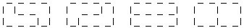

Rotations of patterns are also considered distinct. For example, the following four patterns are distinct:

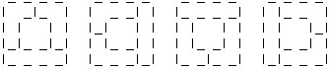

Program Input
Your program must prompt the judge to enter the length and width of the dance floor in feet like the bold face type below. All input is via the keyboard. You can assume that the dance floor will not be larger than 36 square feet. A value of -99 for the length or width measurement should terminate the program.

Enter the length of the dance floor: 2
Enter the width of the dance floor: 4

Program Output
Your program must return the number of distinct patterns that completely cover a dance floor of the given size. If the floor cannot be completely covered, your program must return zero.

There are 4 different patterns that exist for a 2 x 4 dance floor.

Sample Input/Output
Enter the length of the dance floor: 2
Enter the width of the dance floor: 4
There are 4 different patterns that exist for a 2 x 4 dance floor.

Enter the length of the dance floor: 3
Enter the width of the dance floor: 3
There are 0 different patterns that exist for a 3 x 3 dance floor.

Enter the length of the dance floor: 3
Enter the width of the dance floor: 4
There are 23 different patterns that exist for a 3 x 4 dance floor.

